Tin- Sn

The following uses for tin are gathered from a number of sources

- Used to coat other metals to prevent corrosion or other chemical action (tin cans are made from tin coated steel)
- Alloying agent, important alloys include soft solder, type metal, fusible metal, pewter, bronze, bell metal, Babbitt metal, White metal, die casting alloy, and phosphor bronze.
- The chloride (SnCl2.H2O) is used as a reducing agent and as a mordant in calico printing
- Tin salts sprayed onto glass are used to produce electrically conductive coatings. These have been used for panel lighting and for frost-free wind-shields
- Window glass is made by floating molten glass on molten tin (float glass) to produce a flat surface (Pilkington process)
- A crystalline tin-niobium alloy is super-conductive at very low temperatures. Such magnets, made of tin-niobium wire, weigh just a few pounds and produce magnetic fields that are comparable to that of a 100-ton electromagnet.
- Trialkyl and triaryl tin compounds are biocides - there is concern over their environmental effects. Tributyltin is the active ingredient in a type of antifouling paint used on ships.

Table of Contents
1. Thermophysical Properties 3
1. 1 Specific Volume of Sn 3
1. 2 Density of Sn 4
1. 3 Volumetric expansion coefficient (γ) of liquid Sn: 5
1. 4 Compressibility 5
1. 5 Viscosity: 6
1. 6 Surface Tension: 7
1. 7 Vaporization 8
1. 8 Boiling Point 9
1. 9 Heat of Sublimation (L_{s}) and Vaporization (L_{v}): 9
1. 10 Critical Pressure (p_{c}), Temperature (T_{c}), and Volume (V_{c}) 10
1. 11 Heat Capacity 10
1. 12 Electrical Resistivity (ρ) of liquid Sn 11
2. Thermodynamic Properties of Sn 12
2. 1 Enthalpy, Specific Heat, and Entropy of Sn-Vapor 12
2. 2 Heat of Dissociation, Reaction Enthalpy, and Ionization Potentials of Various Tin-Compounds 13
2. 2. 1 Heat of Dissociation 13
2. 2. 2 Reaction Enthalpies 14
2. 2. 3 Ionization Potentials 15
2. 3 Thermodynamic data of Sn-silicates 16
2. 3. 1 Specific heat (c_{p}) of Sn-silicates as a function of temperature 16
2. 4 The Sn-H System 17
2. 4. 1 Hydrogen Solubility 17
2. 4. 2 Absorption of Hydrogen 17
2. 4. 3 H₂-Adsorption 18
2. 4. 4 H₂-Diffusion Coefficient 18
2. 4. 5 Reduction of Sn by atomic hydrogen 18
2. 4. 6 The SnH and SnD Molecule 18
2. 4. 7 Solubility of the gas composition H₂-CO-CO₂ 19
2. 5 The Sn-Li System 19
2. 5. 1 Formation of Li₂SnO₃* 19
Stability of Li₂SnO₃* 19
2. 6 The Sn-C System 20
2. 6. 1 Solubility 20
2. 6. 2 The Sn-C Molecule 20
2. 6. 3 The SnCO₃ Molecule 20
2. 7 The Sn-Si System 21
2. 7. 1 Diffusion of Sn in solid Si 22
2. 7. 2 The Sn-Si Molecule 22
2. 8 Sn and Oxygen 22
2. 8. 1 Low Pressure Oxidation 23
2. 8. 2 Oxidation Mechanism: 23
2. 8. 3 Solubility of O in Sn 23
2. 9 The SnO-SiO₂ System 24
2. 10 General Literature on Corrosion of Sn with Metals: 24

Thermophysical Properties

Specific Volume of Sn
The specific volume of Sn v (in cm³/g) changes from v = 0.1444 at 300°C to v = 0.16554 at 1600°C [1]. Doge tabulated the specific volume as a function of temperature between 200 and 1200°C [2] (see Figure)

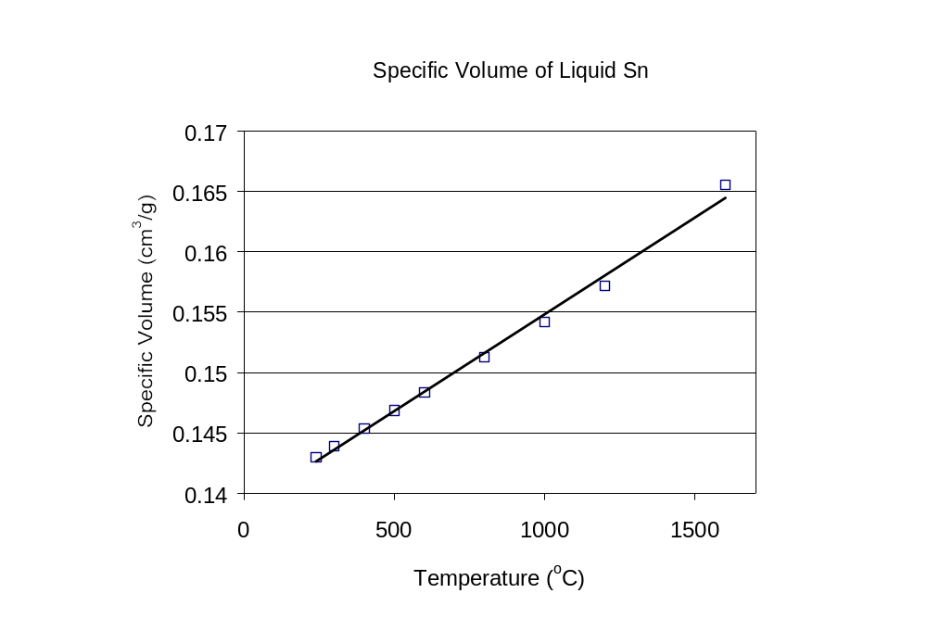
Figure 1: Specific volume of liquid Sn as a function of temperature (after Doge).

- Y. Matuyama, Sci. Rept. Tohoku Univ. I 18 (1929) 19/46, 28.
- G. Doge, Z. Naturforsch. 21a (1966) pp. 266-269.

Density of Sn
The density of Sn has been reported by several authors and is shown in Figure 2. The temperature coefficient of the density (ΔD/ΔT) for liquid Sn has been estimated using γ-ray absorption [1,2]:

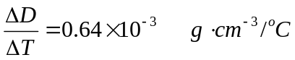 [1]

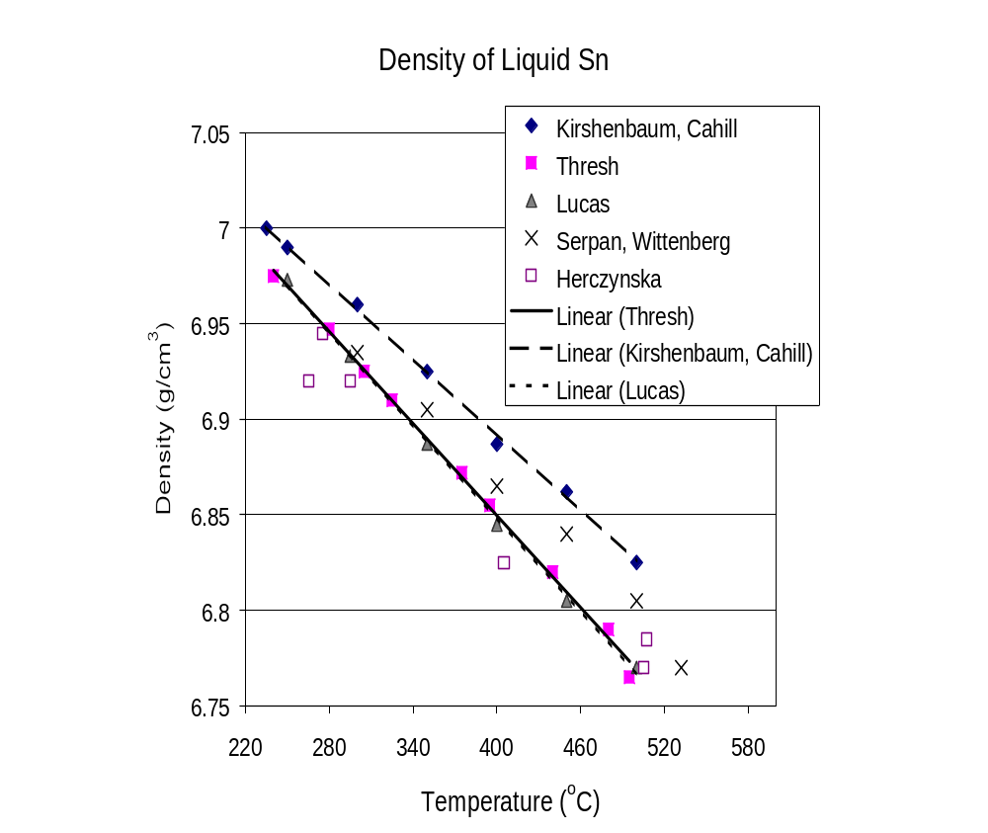
Figure 2: Density of liquid Sn as a function of temperature.

- L. G. Berezkina, A. M. Yakobson, Zavodsk. La. 26 (1960) 171/2; Ind. Lab. [USSR] 26 (1960) 180/1.
- V.A. Grosse, J. Inorg. Nucl. Chem., 22 (1961) pp. 23-31)
- H. R. Thresh, A. F. Crawley, D. W. G. White, Trans. AIME 242 (1968) 819/22.
- E. Herczynska, Naturwissenschaften 47 (1960) 200/1.
- D. Kirshenbaum, J. A. Cahill, Am. Soc. Metals Trans. Quart. 55 (1962) 844/8.
- C. Z. Serpan, L. J. Wittenberg, Trans. AIME 221 (1961) 1017/20.
- L. D. Lucas, Mem. Sci. Rev. Met. 61 (1964)1/24, 11.

Volumetric expansion coefficient (γ) of liquid Sn:
Doge measured the volumetric expansion coefficient between 240 and 1200°C [1]:
γ = 105 x 10⁻⁶/ºC at 240ºC [2]

γ = 96 x 10⁻⁶/ºC at 1200ºC [3]

Widowski measured the average expansion coefficient between 300 and 1600°C to be γ = 113 x 10⁻⁶/ºC [2]

- G. Doge, Z. Naturforsch. 21a (1966) pp. 266-269
- E. Widawski, F. Sauerwald, Z. Anorg. Allgem. Chem., 192 (1930) 145/60, 150.

Compressibility
The coefficient of compressibility χ is used to determine the modulus of compressibility, K (=1/χ) [1]:

K = 4.6 x 10¹¹ dyn/cm² at 232ºC (T_{melt} of Sn)

χ has been reported for 232°C [2], 800°C [3], and 1200°C [2]:

χ = 2.45 x 10⁻¹² cm²/dyn at 232°C

χ = 2.8 x 10⁻¹² cm²/dyn at 800°C

χ = 2.93 x 10⁻¹² cm²/dyn at 1200°C

- [K. H. Schramm, Z. Metallk. 53 (1962) pp. 316-320.
- S. I. Filippov, N. B. Kazakov, L. A. Pronin, Izv. Vysshikh Uchebn. Savedenii Chernaya Met. 9 (1066) 8/14.
- C. M. Gittis, I. G. Mikhailov, Akust. Zh., 11 (1965) 434/7; Soviet Phys.-Acous. 11 (1965) 372/5.

Viscosity:
The viscosity (η given in cP) has been reported between the melting temperature and 1000°C.

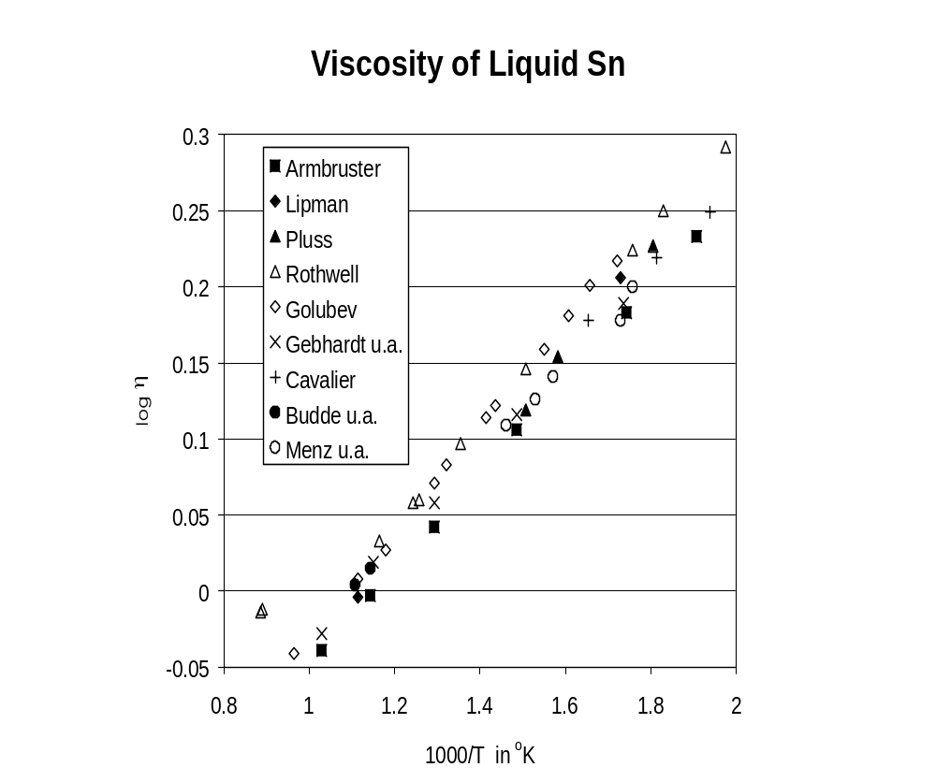
Figure 3: Viscosity of liquid Sn as a function of temperature.

- J. C. Armbruster, Diss. Paris (1961) p. 1-78), M. Pluss, Z. Anorg. Allgem. Chem. 93 (1915) 1/44, 19):
- M. S. Lipman, Zavodsk. Lab 16 (1950) 1349/54.
- M. Pluss, Z. Anorg. Allgem. Chem., 93 (1915) 1/44, 19.
- E. Rothwell, J. Inst. Metals 90 (1962) 38/94, 392.
- F. Golubev, V. A. Petrov, Zavodsk. Lab. 7 (1938) 816/8.
- E. Gebhardt, M. Becker, H. Sebastian, Z. Metallk., 46 (1955) 669/72.
- G. Cavalier, Diss. Paris 1962 in: the Physical Chemistry of Metallic Solutions and Intermetallic Compounds, Bd. 2, 4 D, London 1959, p. 2/12, 7.
- J. Budde, K. Fissher, W. Menz, F. Sauerwald, Z. Physik. Chem. (Leibzig) 218 (1961) 100/7, 105.
- W. Menz, F. Sauerwald, K. Fischer, Acta. Met. 14 91966) 1617/23, 1620.

Surface Tension:
A large scatter in the value of the surface tension (γ in dyn/cm) exists. The scatter is potentially due to measurement techniques and to the impurity levels of the liquid Sn. Results are summarized in the figure below:

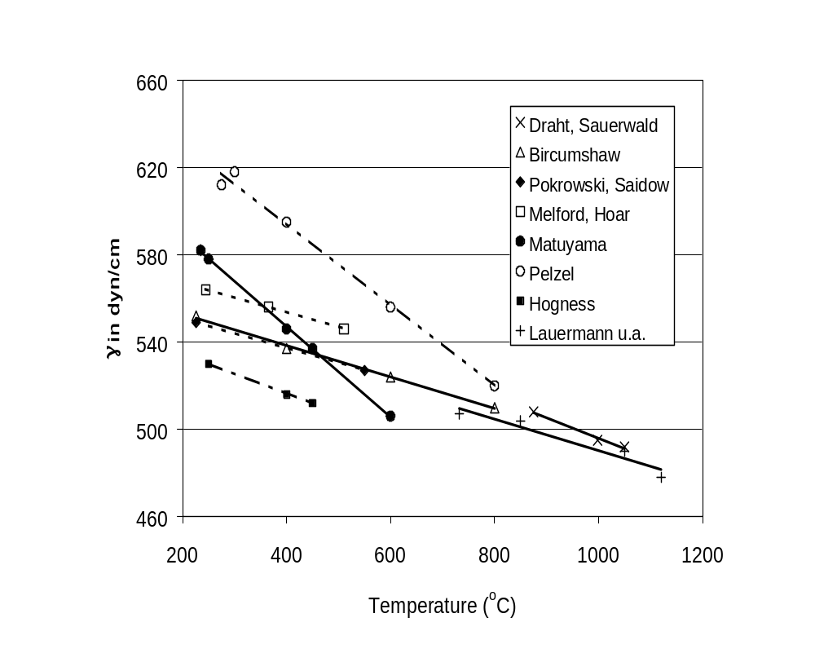
Figure 4: Surface tension of liquid Sn.

- G. Draht, F. Sauerwald, Z. Anorg. Allgem. Chem. 162 (1927) 301/20, 304.
- L.L. Bircumshaw, Phyl. Mag. 17 No. 7 (1934) 181/91, 186.
- N. L. Pokrovskii, m. Saidov, Fiz. Metal. i Metalloved. 2 (1956) 546/51, 550.
- D. A. Melford, T. P. Hoar, J. Inst. Metals 85 (1956/57) 197/205, 201.
- Y. Matuyama, Sci. Rept. Tohoku Univ. I 16 (1927) 555/62, 559.
- E. Pelzel, Berg-Huttenmann. Monatsh. Monta., Hochshule Leoben 93 (91948) 248/54, 252.
- T. R. Hogness, J. Am. Chem. Soc. 43 (1921) 1621/8, 1625.
- Lauermann, G. Metzger, F. Sauerwald, Z. Physic. Chem.[Leibzig] 216 (1961) 42/9, 43).

Vaporization
Mass-spectroscopy of Sn-vapor shows the presence of positive ion-clusters:
Sn₂, Sn₃, Sn₄, Sn₅ and Sn₆ (G. Kohl, Z. Naturforsch. 9a (1954) 913/8, 918).

The vapor pressure of Sn between 500°C and 1200°C has been measured [1] and is given the following figure. Measurements between 800°K and 2940°K have been reported by Honig [2]. For a limited temperature range between 1424 and 1638°K the following expression can be used for the vapor pressure [3]:

lg p_{k} = 5.471 –15730/T (p in atm, T in °K) [4]

lg p_{T} = 5.810 –16160/T (p in atm, T in °K) [5]

where the subscript K indicates measurements using the Knudson effusion method, and T a torsion-based method. Given the spread of experimental data, Nemeyanov derived a general expression for the vapor pressure [4] as:

lg p = – 9.32188 – 14023.92/T – 8.812210⁻⁴T + 5.6201 lg T [6]

where the pressure is in atm and the applicable temperature range is 1424<T<1753 °K.
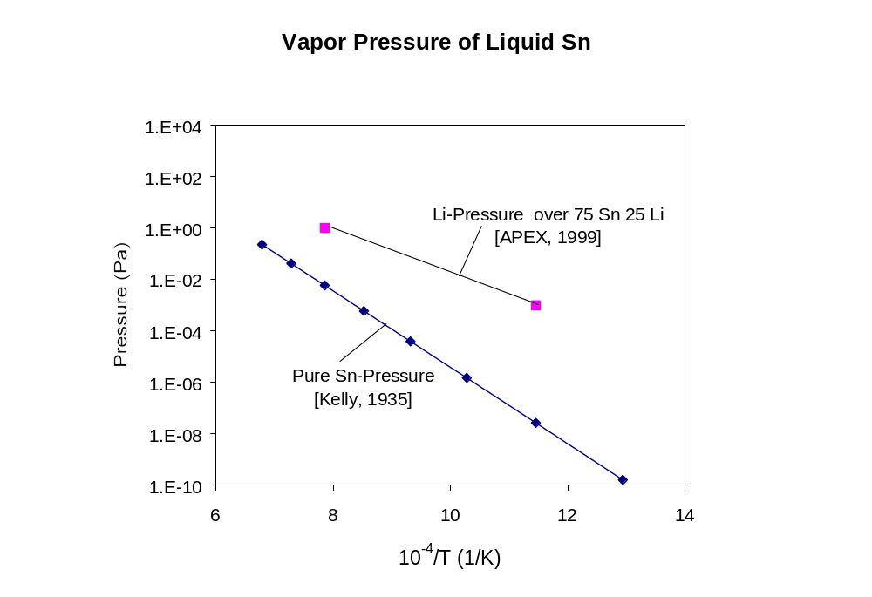
Figure 5: Vapor pressure of pure Sn and 75 Sn- 25 Li mixture.

- K. K. Kelly, U.S. Bur. Mines Bull. Nr. 383 (1935) 1/132, 105.
- R. E. Honig, D. A. Kramer, RCA Rev. 30 (1969) 285/305, 297.
- L. Brewer, R. F. Porter, J. Chem. Phys. 21 (1953) 2012/3.
- A. N. Nesmeyanov, Dablenie Para Khimicheskikh Elementov, Moskva 1961, p. 231,369; Vapour Pressure of the Elements, London 1963, P. 273, 445.
- M. Abdou, et al., “On the Exploration of Innovative Concepts for Fusion Chamber Technology: APEX Interim Report,” University of California School of Engineering and Applied Science, UCLA-ENG-99-206, Nov. 1999.

Boiling Point
At 760 Torr the boiling point of Sn has been measured [1] to be:

T_{boil} = 2780 ± 20 °K [7]

A boiling point values of 3000°K has been reported [2]. It is speculated that the spread in boiling point may be caused by the formation of complex gases.

- D. T. Stull, G. C. Sinke, Thermodynamic Properties of the Elements, Washington 1956, p. 33.
- L. L. Quill, The Chemistry and Metallurgy of Miscellaneous Materials, Thermodynamics, New York – Torronto – London 1950, p. 33.

Heat of Sublimation (L_{s}) and Vaporization (L_{v}):
The heat of sublimation at 298°K and 232°C have been reported [1,2]

L_{s} = 71.9 ± 2.0 kcal/mot at 298°K: [8]

L_{s} = 71.9 ± 1.5 kcal/mot at 232°C [9]

The heat of vaporization is given by [2]:

L_{v} = 70.8± 1.5 kcal/mot at 2623°C [10]

The melting temperature of Sn is 232°C and its boiling temperature is 2623°C.

- W. Searcy, R. D. Freeman, J. Am. Chem.Soc. 76 (1954) 5229/32.
- O. Kubaschewski, W. L. Wvans, C. B. Alcock, Metallurgical Thermochemistry,4. Aufl., Oxford 1967, p. 385.

Critical Pressure (p_{c}), Temperature (T_{c}), and Volume (V_{c})
These were reported by Searcy and Freeman [1] and Gates [2]:

T_{k} = 5809°K
p_{c} = 524 atm
V_{c} = 264.9 cm³/mol

- A. W. Searcy, R. D. Freeman, J. Am. Chem. Soc. 76 (19540 5229/32.
- D. S. Gates, G. Thodos, A.I.Ch.E. (Am. Inst. Chem. Engrs.) J 6 (1960) 50/4.

Heat Capacity
The heat capacity at the melting point (232°C) has been reported to be [1]
C_{p} = 7.10 cal/(mol-°K). Raising the temperature to 800°C reduces the heat capacity from 7.10 to C_{p} = 6.87 cal/(mol-°K). An expression for the heat capacity as a function of temperature is given by [1]:

Cp = 9.97 – 9.15  10⁻³T + 6.5  10⁻⁶T² [11]

- T. W. Chapman, Mater. Sci. Eng. 1 (1966) 65/9

Electrical Resistivity (ρ) of liquid Sn
At the melting temperature the electrical resistivity (ρ) of Sn doubles from
ρ_{s} = 22.8 μΩ-cm to ρ_{l} = 48.0 μΩ-cm [1]. There is a large scatter in the reported data of ρ. See the figure below.

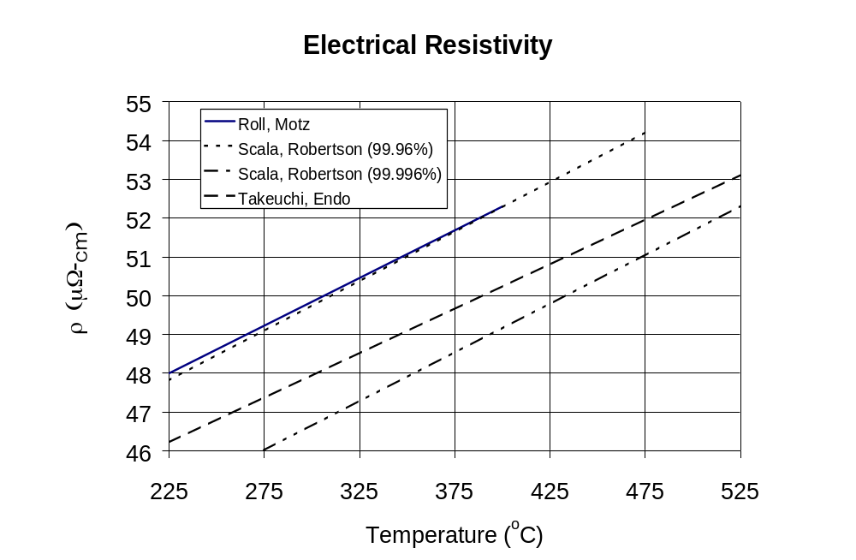
Figure 6: Electrical resistivity of liquid Sn as a function of temperature.

The following temperature dependent correlations have been established
(ρ in μΩ-cm; T in °C):

ρ = 40.88 + 0.0272 T for T < 315°C [12]

ρ = 41.16 + 0.0263 T for T > 315°C [13]

- A. Roll, H. Motz, Z. Metallk. 48 (1957) 272/80, 274.
- E. Scala, W. D. Robertson, J. Metals, 5 (1953) Trans. 197, p. 1141/7, 1144.
- S. Takeuchi, H. Endo, Trans. Japan Inst. Metals 3 (1962) 30/5.
- H. A. Davis, J. S. L. Leach, Phys. Chem. Liquids 2 (1970) 1/12, 5.
- P. D. Adams, Diss. Univ. of London, 1964

Thermodynamic Properties of Sn

Enthalpy, Specific Heat, and Entropy of Sn-Vapor
Thermodynamic values of enthalpy, specific heat, and entropy have were determined spectroscopically assuming that Sn-vapor obeys the ideal gas law [1-3].

Table: Thermodynamic values of Sn-vapor
Temperature  (°K) | H°– H°_{298.15}  (kcal/mol) | C°_{p}  (kcal/mol-°K) | S°  ()
298 | 0 | 5.08 | 40.24
400 | 535 | 5.47 | 41.79
600 | 1747 | 6.66 | 44.22
800 | 3179 | 7.57 | 46.28
1000 | 4735 | 7.91 | 48.01
1400 | 7866 | 7.62 | 50.65
1800 | 10805 | 7.09 | 52.20
2200 | 13555 | 6.69 | 53.88
2600 | 16178 | 6.44 | 54.98
3000 | 18717 | 6.27 | 55.89
3200 | 19964 | 6.199 | 56.29
3400 | 21198 | 6.139 | 56.66
3600 | 22420 | 6.086 | 57.01
3800 | 23633 | 6.038 | 57.34
4000 | 24836 | 5.995 | 57.65
4400 | 27218 | 5.919 | 58.22
4800 | 29573 | 5.859 | 58.73
5200 | 31907 | 5.815 | 59.20
5600 | 34228 | 5.791 | 59.63
6000 | 36543 | 5.790 | 60.02

Heat of Dissociation, Reaction Enthalpy, and Ionization Potentials of Various Tin-Compounds

The heat of dissociation 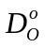(kcal/mole) is defined as:
[14]
where 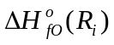is the enthalpy of formation at 0°K and R_{i} is reactant i.

Heat of Dissociation

Compound | D_{o} (kcal/mole) [1]
Sn₂ | 46 ± 4
SnAg | 32 ± 5
SnAu | 60 ± 4
SnCu | 42 ± 4
SnBr | 80 ± 1
SnBr⁺ | 80 ± 12
SnCl | 98 ± 4
SnF | 112 ± 3
SnF⁺ | 112 ± 12
SnH | 60 ± 3
SnI | 55 ± 2
SnO | 126 ± 2
SnO⁺ | 53 ± 15
SnS | 110.2 ± 0.8
SnS⁺ | 55 ± 12
SnSe | 95 ± 8
SnSe⁺ | 40 ± 12
SnTe | 75.0 ± 1.0
SnTe⁺ | 36 ± 12

Reaction Enthalpies

Reaction | ΔH_{fO} (kcal/mole) [1] | ΔH_{f298} (kcal/mole) [1]
SnO = Sn + O | 126 ± 2 | 127
(SnO)₂ = 2SnO |  | 66 ± 4
(SnO)₃ = (SnO)₂ + SnO |  | 69 ± 6
(SnO)₄ = (SnO)₃ + SnO |  | 71 ± 7
(SnO)₄ = 2(SnO)₂ |  | 74 ± 9
SnF = Sn = F | 112 ± 3 | 112
SnF₂ = SnF + F |  | 105
(SnF₂)₂ = 2SnF₂ |  | 41
(SnF₂)₃ = (SnF₂)₂ + SnF₂ |  | 30
SnCl = Sn + Cl | 98 ± 4 | 98
SnCl₂ = SnCl + Cl |  | 81
SnBr = Sn + Br | 80 ± 1 | 80
SnBr₂ = SnBr + Br |  | 74
SnI = Sn + I | 55 ± 10
SnI₂ = SnI + I |  | 66 ± 10
SnS = Sn + S | 110.2 ± 0.8 | 111.1
Sn₂S₂ = 2SnS |  | 49 ± 5
Sn₂S₂ =Sn₂ + S₂ |  | 126 ± 6
SnSe = Sn + Se | 95 ± 5
Sn₂Se₂ = 2SnSe |  | 46.5 ± 0.4
Sn₂Se₂ = Sn₂ + Se₂ |  | 119 ± 10
SnTe = Sn + Te | 75.0 ± 1.0 | 75.6
SnTe₂ = SnTe + Te |  | 48.9 ± 3.0
SnTe₂ = SnTe + 1/2Te₂ |  | 17.5 ± 0.3
SnTe₂ = Sn + Te₂ |  | 61.7 ± 2.0
Sn₂Te₂ = SnTe₂ + Sn |  | 73.6 ± 8.0
Sn₂Te₂ = 2SnTe |  | 46.9 ± 6.0
Sn₂Te₂ = Sn₂ + Te₂ |  | 90 ± 8
SnWO₄ = SnO + WO₃ | 136 ± 15
Sn₂WO₅ = SnO + SnWO₄ | 66 ± 15

Ionization Potentials

Compound | Ionization Potential (eV) [1]
SnO | 10.5 ± 0.5
Sn₂O₂ | 9.8 ± 0.5
Sn₃O₃ | 9.8 ± 0.5
Sn₄O₄ | 9.2 ± 0.5
SnH₄ | 9.2 ± 1.0
Sn₂H₆ | 9.0 ± 0.3
SnF | 7.4 ±0.5
SnF₂ | 11.5 ± 0.5
SnCl | 6.6 ± 0.5
SnCl₂ | 10.2 ± 0.5
SnCl₃ | 9.5 ± 0.5
SnCl₄ | 11.5 ± 0.5  12.10 ± 0.05
SnBr | 7.4 ± 0.5
SnBr₂ | 10.0 ± 0.4
SnBr₃ | 9.1 ± 0.5
SnBr₄ | 10.6 ± 0.4  11.0 ± 0.1
Sn₂F₄ | 10.5 ± 0.5
Sn₃F₆ | 10.5 ± 0.5
SnS | 9.7 ± 0.5
Sn₂S₂ | 9.4 ± 0.5
SnSe | 9.7 ± 0.5
Sn₂Se₂ | 9.8 ± 0.5
SnTe | 9.1 ± 0.5

- [D. R. Stull, G. C. Sinke, Thermodynamic Properties of the Elements, Washington 1956, p. 209.
- R. Hultgren, R. L. Orr, P. D. Anderson, K. K. Kelly, Selected Values of Thermodynamic Properties of Metals and Alloys, New York – London, 1963, p. 262.
- J. S. Gordon, ADI-6930 (1961) 1/3.
- L. V. Gurvich, et al., “Heat of Dissociation of Chemical Bonds and Ionization Potentials,” Published by Nauka, Moskow, 1974.

Thermodynamic data of Sn-silicates
Enthalpy of formation (ΔH), free energy of formation (ΔG) in kcal/mol and entropy of formation (ΔS) in cal/mol-ºK between 298 and 1500ºK have been estimated [1]:

Table: Thermodynamic data for Sn-silicates

Compounds | -ΔH₂₉₈ | -ΔG₂₉₈ | ΔS₂₉₈
SnSiO₃ | 270 | 252 | 24.19
Sn₂SiO₄ | 301.2 | 283.38 | 34.93

- D. E. Wilcox, Ind. Eng. Chem. 55 No.7 (1963) 32/9, 37.

Specific heat (c_{p}) of Sn-silicates as a function of temperature
For SnSiO₃ [1]:
c_{p} = 24.06 + 9.32x10⁻³T – 2.35x10⁻⁵T² cal/mol-ºK [15]

and for Sn₂SiO₄:
c_{p} = 33.026 + 14.31x10⁻³T – 2.09x10⁻⁵T² cal/mol-ºK [16]

- V. A. Gorochovskii, E. A. Kregius, V. A. Vlasov, T. B. Dashkevich, Izv. Akad. Nauk SSSR Neorgan. Materialy 7 (1971) 2033/5; Inorg. Materials (USSR) 7 (1971) 1810/2.

The Sn-H System
At room temperature, molten Sn does not absorb any H₂ [1]. At 1000°C 100 g Sn will dissolve 1.77 cm³ of H₂ [2]. Between 1150 and 1300°C no dissolution of H2 in liquid Sn is observed, based on monitoring the H₂ pressure [3]. However, hydrogen pressures above 10 Torr indicate some dissolution of H₂ [4]. Atomic hydrogen reacts with Sn and forms SnH₄[5].

- A. Sieverts, Z. Elektochem. 16 (1910) 707/13, 708.
- K. Iwase, Sci. Rept. Tohoku Imp. Univ. I 15 (1926) 531/66, 543.
- R. Schafer. W. Klemm, J. Pract. Chem. [4] 5(1(58) 233/41, 240.
- E. Bauer, R. Brunner, Helv, Chi, Acta 17 (1934) 958/69.
- T. G. Pearson, P. L. Robinson, E. M. Stoddart, Proc. Roy. Soc. [London] A 142 (1933) 275/85, 280.

Hydrogen Solubility

Temperature (ºC) | H₂ (cm³) /100 g Sn | References
800 | 0.3 | [1]
1000 | 1.77 | [2]
1000-1300 | 0.02 – 0.43 (@1atm) | [3]

- [L. L. Bircumshaw, Phil. Mag.[71] 1 (1926) 510/22, 513.
- [K. Iwase, Sci. Rept. Tohoku Imp. Iniv., 15 (1926) 531/66, 544.
- [M .B. Bever, C F. Floe, Trans. AIME, 156 (1944) 149/59.

Absorption of Hydrogen
At room temperature, molten Sn does not absorb any H₂ [1]. At 1000°C 100 g Sn will dissolve 1.77 cm³ of H₂ [2]. Between 1150 and 1300°C no dissolution of H2 in liquid Sn is observed, based on monitoring the H₂ pressure [3]. However, hydrogen pressures above 10 Torr indicate some dissolution of H₂ [4]. Atomic hydrogen reacts with Sn and forms SnH₄[5].

- A. Sieverts, Z. Elektochem. 16 (1910) 707/13, 708.
- K. Iwase, Sci. Rept. Tohoku Imp. Univ. I 15 (1926) 531/66, 543.
- R. Schafer. W. Klemm, J. Pract. Chem. [4] 5(1(58) 233/41, 240.
- E. Bauer, R. Brunner, Helv, Chi, Acta 17 (1934) 958/69.
- T. G. Pearson, P. L. Robinson, E. M. Stoddart, Proc. Roy. Soc. [London] A 142 (1933) 275/85, 280.

H₂-Adsorption
Measurements of the surface tension of Sn in a low pressure H₂-atmosphere showed that the number of adsorbed H₂-molecules is about 10% the total number of surface Sn-atoms. Results of statistical thermodynamic calculations have estimated the adsorption energy to be about:

E_{adsorp} = 12.67 kcal/mol

which is similar to the adsorption energy of di-atomic gas molecules on solid metal surfaces [1].

- M. Ishigura, Mem. Int. Sci. Ind. Res. Osaka Univ., 8 (1951) 78/82.

H₂-Diffusion Coefficient
The diffusion coefficient of H₂ in liquid Sn is larger than that of H₂ in liquid Ag, Cu, and Ni [1].

- E. M .Sacris, N. A. D. Parlee, Met. Trans., 1 (1970) 3377/82.

Reduction of Sn by atomic hydrogen
Glow discharge experiments in the presence of dilute H₂-gas has shown the production of SnH₄ only in the presence of hydrocarbons (catalytic reactions).

The SnH and SnD Molecule
Based on the size difference of 0.532 A between the atomic radius and the radius of the outer orbit, Pollitzer [1] concludes that the H-atom has to overcome a larger barrier to attachment to Sn than to metal in the I and III group.

Significant detail is available on the electron configuration, the rotational and vibrational constants and the inter-nuclear distances of the SnH and SnD molecules.

The dissociation energy has been calculated to be:
E_{diss} = 2.7 eV

- P. Pollitzer, J. Phys. Chem., 70 (1966) 4041/4.

Solubility of the gas composition H₂-CO-CO₂
The solubility of the gas composition H₂-47, CO-45, CO₂-0.8 (Vol. %) was measured between 1000° and 1300°C.

Temperature (ºC) | H₂-CO-CO₂ (cm³) /100 g Sn | Ref.
1000-1300 | 5 – 12 | [1]

- S. B. Delachanal, Compt. Rend. 148, 1909) 561/4.

The Sn-Li System
Li₂SnO₃ is a stable crystalline solid above 1000ºC.

Formation of Li₂SnO₃*

Compounds | Formation Temp. (ºC) | Stability of Li₂SnO₃* | References
SnO₂ ; Li₂O | 800 | α-Phase:  stable below 800ºC  β-Phase:  stable above 1000ºC | [1]
SnO₂ ; Li₂OC₃ | 1000 | α-Phase:  stable below 800ºC  β-Phase:  stable above 1000ºC | [2]

* Li₂SnO₃ is formed from the solid compounds with an approximate molar fraction of 1;1.05, by heating at the formation temperature for about 10 hr.

Li₂SnO₃ is luminescent when exposed to UV-rays (2537 ), or α-rays (Po-based 5.6 MeV α’s). TiO2 activated Li₂SnO₃ can be used as a neutron scintillator, because the α-energy from the ⁶Li(n,α)³H reaction is of the same range as the α’s from Po.

Li₂SnO₃ is stable in H₂O or methanol. Equimolar mixtures of LiO₂ and Li₂SnO₃ heated at 360ºC show no sign of dissolution, however, between 450 and 900ºC partial formation of Li₈SnO₆ has been reported [1,3] (Li₈SnO₆ is stable up to 1000ºC; melts at 1050ºC [5])

- D. Rade, Diss. Karlsruhe T. H. !958, p. 60
- F. Hund, G. Lang, Naturwissenschaften 38 (1951) 502/3.
- W. Pucall, Silicat-Z., 2 (1914) 65/76.
- D. Rade, Diss. Karlsruhe T. H. !958, p. 64/6.

The Sn-C System

Solubility
Liquid Sn dissolves only trace amounts of C (14.3-p217 [1]). For all practical applications, Sn and C are immiscible. Estimates of solubility are given by [1]:

lg x_{c} = -13800/T + 0.315 [17]

where x_{c} is the mole fraction of C and T is in ºK.

- O. Ruff, B. Bergdahl, Z. Anorg. Allgem. Chem., 106 (1919) 76/94, 91.

The Sn-C Molecule
The binding energy of the a Sn-C molecule has been estimated to be [1]:
E_{bind} = 60 kcal/mole

The vibration frequency (ω) of this molecule has been estimated to be between 944.4 to 1021 cm⁻¹. [2,3].

- M. L. Huggins, J. Am. Chem. Soc., 75 (1953) 4123/4, 4125.
- Y. P. Varshni, Z. Physik. Chem. (Leibzig), 204 (1955) 188/93, 191.
- P. L. Goodfriend, Can. J. Phys. 45 (1967) 3425/7.

The SnCO₃ Molecule
The enthalpy of formation of SnCO₃ has been estimated to be [1]:
ΔH₂₉₈ = -177 kcal/mole
and that of the formation of Sn(HCO₃)₂ has been estimated to be [1]:
ΔH₂₉₈ = -353 kcal/mole
and the partial pressure of CO₂ for a hypothetical carbonate of Sn [Sn(CO₃)₂] has been estimated to be [2]:

lg p_{CO2} = -895.T + 9.803 (p in atm; T in °K) [18]

A related molecule, Sn(HCO₂)₂ has an enthalpy of formation given by [3]:
ΔH = -209 ± 15 kcal/mole
Although this compound (Tin-formiate) is stable in air and in vacuum, it does dissociate when heated between 198 and 200ºC, without first melting.

- D. E. Wilcox, Ind. Eng. Chem., 55 No. 7 (1963) 32/9, 3.
- E. Erdos, Collection Czech. Chem. Commun., 27 (1962) 2152/67, 2165.
- get from library

The Sn-Si System
Investigations of Sn-Si compounds have been reported only sporadically, with most of the attention given to the SnO-SiO₂ system. Thermodynamic measurements indicate the existence of the Sn₂SiO₄ compound, which can be prepared by melting the tow oxides [1,2].

Tin and Si form, what is called a “degenerative” eutectic near the melting temperature of Sn (232ºC). For all practical purposes, Si is insoluble in liquid Sn. The solubility of Si in Sn at 1100°C is about 10 at.%, but increases as the melting temperature of Si (1417°C) is reached [1].

The solubility of Sn in solid Si at 800°C and up to 1412°C has been measured as [3]:
k = 6.5x10⁻⁴ at 800°C
k = 6.5x10⁻² at 1412°C

The enthalpy of mixing at 50 at. % is given by [4]:
ΔH = 1.300 kcal/g-atom

and for solid Sn in liquid Si, it is [5]:
ΔH = 9.160 kcal/g-atom

- S. Tamaru, Z. Anorg. Allgem. Chem., 61 (1909) 40/5, 41.
- W. Johnson, M. Hansen, AF-TR-6383 (1951) 1/133, 21, 76; N. S. A. 5 (1951) No. 6757.
- F. A. Trumbore, C. R. Isenberg, E. M. Porbansky, Phys. Chem. Solids 9 (1959) 60/9, 63.
- W. Ptak, Arch. Hutnictwa, 1 (1956) 53/97, 91.
- G. M. Kuznetsov, S. K. Kuznetsova, Izv. Akad. Nauk SSSR Neorgan. Materialy 2 (1966) 643/9; Inorg. Materials (USSR) 2 )1966) 555/60, 557.

Diffusion of Sn in solid Si
Between 800°C and 1200°C the diffusion zone of Sn in solid Si rises with increasing temperature. Above 850°C the diffusion rate increases exponentially from 100 nm. The activation energy for Sn diffusion in Si has been estimated to be 7.3 kcal/mole [1,2] and for Si in liquid Sn it is 5 kcal/mole.

- V. N. Lozovskii, A. I. Kalinyuk, V. I. Buddo, Tr. Novocherk. Politekhn. Inst. (1970) No. 208, p. 50/4.
- V. N. Lozovskii, A. I. Kalinyuk, Fiz. Kondens. Sred., (1969/70) 87/90.

The Sn-Si Molecule
The binding energy of the hypothetical Sn-Si molecule has been estimated to be [1]:
E_{bind} = 37.0 kcal/mole at 300°K

The vibration frequency (ω) of this molecule has been estimated to be between 555.6 to 608 cm⁻¹ [2,3].

- P. Manca, Phys. Chem. Solids 20 (1961) 268/73, 269.
- Y. P. Varshni, Z. Physik. Chem. (Leibniz) 204 (1955) 188/93, 191.
- P. L. Goodfriend, Can. J. Phys. 45 (1967) 3425/7.

Sn and Oxygen
In dry air Sn is stable against oxidation at room temperature [1]. The time to develop a layer of oxide (yellow discoloration) has been estimated to be about
38  10⁸ years [2].

A relative humidity of 80% increases the oxidation rate by a 50% compared with that in dry air [3]. In the presence of H₂O, Sn shows distinct discoloration after 100 days, and in flowing air oxidation becomes visible within 14 days [4]. Oxidation in humid air results in the formation of an oxide layer, which prevents further oxidation at room temperature. A rise in temperature increases the oxidation rate.

The oxide, which forms with pure O₂ between 0 and 200°C is a α-SnO [5]. Above 280°C both SnO and SnO₂ form, while above 390°C only SnO₂ will form [6]. When Sn powder with an average diameter of 2.5  10⁻⁶cm is molten at 505°C a 50  thick SnO layer is formed [7].

Low Pressure Oxidation
At low pressures, 2  10⁻⁴ Torr, oxidation results only in the formation of SnO regardless of the temperature. At a higher pressure of 5  10⁻³ Torr SnO forms up to a temperature of 400°C. With an increase in temperature SnO₂ starts to form, and above 630°C only SnO₂ forms [8].

Oxidation Mechanism:
The oxidation of Sn starts with the formation of oxide-nuclei, which were measured to be of the order of 2  10⁶ cm⁻² at an oxygen pressure of above 1 torr. These nuclei consist of oriented α-SnO platelets, which grow until they cover about 80% of the surface area. This phase constitutes the fasted oxidation rate. Following the coalescence of the platelets, a logarithmic growth rate sets in, which is dictated by the rate of diffusion of liquid Sn to the surface between the platelets. The rate of diffusion of Sn through the space between the plateles is slow, because of the formation of cavities, which act as diffusion barriers to Sn.
At 220°C and an oxygen pressure of 10 torr, about 1/3 of the surface layer consists of these cavities [9]. The presence of these cavities is responsible for the logarithmic oxidation rate instead of a common parabolic rate. At oxygen pressures below 0.1 Torr the formation of α-Sn dendrites instead of platelets is observed.

Solubility of O in Sn
The rate of solution of O in molten Sn at 536, 600, and 700°C is 10⁻⁸, 7  10⁻⁸, and 10⁻⁷ g/h, respectively, and the solubility limit at each of these temperature is 6  10⁻⁶, 2 10⁻⁴, and 6  10⁻⁴ at. % of O. The enthalpy and entropy of solution of O in Ne per g-atom oxygen is [10]:
ΔH = -43870 ± 1000 cal/g-atom
ΔS = -15.74 ± 1.10 cal-g/atom-°K

Between 780 and 1180°C the enthalpy of solution and entropy are given by [11,12]:
ΔH° = - 46060 cal/g-atom
ΔS° = -11.98 cal-g/atom-°K

- M. Traube, Ber. Deut. Chem. Gas. 18 (1885) 1877/1885.
- G. Tammann, W. Koster, Z. anorg. Chem. 123 (1922) 196/224, 208.
- S. C. Britton, K. Bright, Metallurgia 56 (1957) 163/8.
- L. Kenworthy, Trans. Faraday Soc. 31 (1935) 1331/45, 1333.
- C. Luner, Trans. AIME 218 (1961) 13/24, 21.
- G. Shimaoka, I. Yamai, J. Chem.Soc. Japan Pure Chem. Sect. 76 (1955) 965/7.
- Yu. I. Petrov, Fiz. Metal, I metalloved, 19 (1965) 219/25.
- J. J. Trillat, L . Tertian, M. T. Plattard, Compt. Rend. 240 (1955) 526/9.
- W. E. Boggs, P. S. Trozzo, G. E. Pellissier, J. Electrochem. Soc. 108 (1961) 13/24.
- T. N. Belford, C. B. Alcock, Trans. Faraday Soc. 61 (1965) 443/53, 447. 451.
- W. A Fischer, Arch. Eisenhuttenw. 38 (1967) 422/9, 428.
- W. A Fischer, Arch. Eisenhuttenw. 37(1966) 697,700.

The SnO-SiO₂ System
The system SnO – SiO₂ exhibits a eutectic at 865°C with a concentration of 66.1 wt% SnO. A concentration of 54.6 wt% SnO results in melting at 1160°C. Dissolution of SiO₂ by liquid SnO results in the formation of Sn-silicate above 1040°C. Between 1200 and 1250°C the mixture of molten SiO₂ and SnO results in the formation of Sn₂SiO₄, which is a black crystalline substance. SnSiO₃, which forms around 900°C has a gold-yellow appearance [1,2].

The activity of SnO (a_{SnO}) in SnO-SiO₂ melts has been determined as a function of SnO molar fraction at 1000, 1050, 1100, and 1150ºC [3].

- B. I. Slonimskii, A. A. Tseidler, Sb. Tr. Gos. Nauchn. Issled. Inst. Tsvetn. Metal, 1959, No. 15, P. 173/9, 174.
- B. Keysselitz, E. J. Kohlmeyer, Metall Erz 30 (1933) 185/90, 189.
- D. M. Chizhikov, M. E. Vokaova, Yu. V. Tsvetkov, Izv. Akad. Nauk SSSR Met. I Gorn. Delo, 1964, No. 3, p. 82/90, 83.

General Literature on Corrosion of Sn with Metals:

- F. A. LowenHeim, R. A. Woofter, R. R. Hartwell, Tin and Tin Plate in: F. L. LaQue, H. R. Copson, Corrosion Resistance of Metals and Alloys, 2nd edition, New York – London 1963, p. 259/84
- F. Ritter, Korrosionstabellen metallischer Werkstoffe, 3rd edition, Wien 1952.
- E. Rabald, Corrosion Guide, New York – Amsterdam – London – Brussel 1951.
- W. Gonser, J. E. Strader, Tin in: H. H. Uhlig, Corrosion Handbook, New York – London 1948, p. 323/9.
- W. Wiederholt, Zinn in: O. Bauer, et al., “Die Korrosion metallischer Werkstoffe,” 2nd edition, Leibzig 1938, p. 699/721.

Nightingale, Richard Edwin, 1926-. Nuclear graphite., [Contributors: D.E. Baker and others] Prepared under the auspices of the Division of Technical Information, U.S. Atomic Energy Commission. New York, Academic Press, 1962. 547 p. illus. 25 cm. Language: English [Long Display] Library
Call Number Other Information
UCB Engin TK9202 .N54 (circ status) UCR Science TK9202 .N53 (circ status) UCSD
S & E TK9202 .N688 (circ status) NRLF TK9202.N5 SRLF A 0002424356

Journal of inorganic and nuclear chemistry. Issues published: v. 1-43; no. 11; Mar. 1955-81. Publication info: Oxford, New York [etc.] Pergamon Press. Physical description: v. ill., diagrs. 26 cm. Subject: Chemistry, Inorganic--Periodicals. Subject: Nuclear chemistry--Periodicals. COPY MATERIAL LOCATION CALL NUMBER for: SCI&ENG 1) PERIODICAL SECTION V.1-3,6-43 1955-1981 1 NO-LOAN JRNLSTACKS

Personal author: Hultgren, Ralph Raymond, 1905- Title: Selected values of thermodynamic properties of metals and alloys [by] Ralph Hultgren [and others]. Publication info: New York, Wiley [1963] Physical description: 963 p. illus. Series: (Wiley series on the science and technology of materials) Subject: Metals Subject: Alloys Subject: Thermodynamics COPY MATERIAL LOCATION CALL NUMBER for: SCI&ENG 1) QD171.H88 1 4WK/SEMSTR BOOKSTACKS

LaQue, Francis L. 1904-. Corrosion resistance of metals and alloys. 2d ed. edited by F. L.
LaQue and H. R. Copson. New York, Reinhold Pub. Corp. [1963] xii, 712 p. illus., diagrs.,
tables. 24 cm.
Series title: American Chemical Society. Monograph series no. 158., Monograph series
(American Chemical Society) no. 158.

